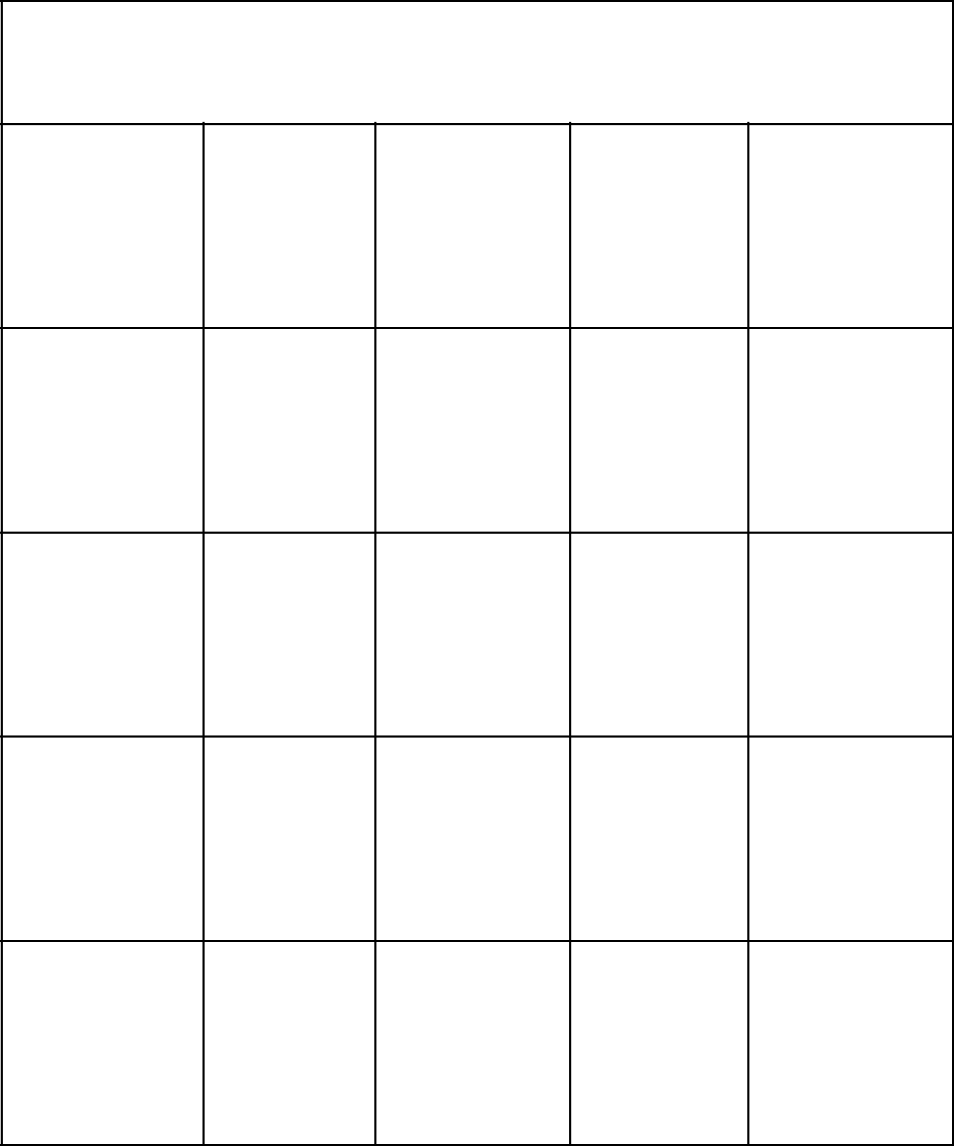**Schechter Experiences Bingo**

|  |  |  |  |
| --- | --- | --- | --- |
| JS | Touching | Imperialism Speak Kindergarten |  |
| The Lights |  |

|  |  |  |  |  |
| --- | --- | --- | --- | --- |
| Partners | Wrap and | Who Loves | The | Siddur |
| with God | Strap | America? | Outsiders | Ceremony |

|  |  |  |  |  |  |
| --- | --- | --- | --- | --- | --- |
| B’nai | Schechter | **FREE** | Chanukah | LA |  |
| Mitzvahs | Bucks | **Free Space** | Assembly |  |
|  |  |

|  |  |  |  |  |  |
| --- | --- | --- | --- | --- | --- |
| Chromebook | Soccer | Musical | Coach | 8th Grade |  |
| Jail | Team | Doug |  |
|  |  |  |

|  |  |  |  |  |  |
| --- | --- | --- | --- | --- | --- |
| Tikkun | Kehillah | Ultimate | 8th Grade | Hebrew |  |
| Ceremony | Frisbee | Shabbaton |  |
|  |  |  |



**Schechter Experiences Bingo**